Technical Paper: Tech:2-22062012

Project Title: Understanding functional connectivity in resting state: a network based approach

**Phase 2: Graph analysis of fMRI resting state functional networks**.

Author(s): Jaime Gomez-Ramirez

Biomedical Engineering Laboratory

Okayama University

**Introduction**

In this technical paper we specifically address the use of network theory (graphs) to analyze resting-state functional connectivity. Graph analysis studies “complex” systems described as pairwise relations between elements. Thus we need to very clearly understand the nature of the nodes and the links of our graph. Using fMRI data, the nodes are brain locations, so depending on whether we are doing a local or global study the nodes can be whole brain areas, ROIs, or even voxels. There is not a unique way to quantify the links between those nodes, in (Sanz-Agirita:2010) use synchronization likelihood (SL), which provides a measure of the dependencies between BOLD time series acquired during resting condition.

In conclusion, the aim of this stage of the project is to build a graph in which the nodes are brain regions with activity pattern associated, and the links represent a relevant inter-node synchronization levels (above a threshold).

**Types of connectivity**

It is typically assumed that exists three types of network connectivity in the brain:

1. Anatomical (or structural) connectivity: Study of white matter tracts in histological studies. It does not posses major difficulties
2. Functional: Study of temporal correlations between pairs of anatomically unconnected regions
3. Effective: Represent direct or indirect causal influences observed from perturbations

Functional and Effective connectivity are based on the study of temporal series of brain dynamics.

In the context of BOLD signal:

1. Functional: cross correlations between BOLD signals (adjacency matrix)
2. Effective: patterns of causal interactions (transfer entropy)

The adjacency matrix can be Binary (easy to define the NULL model) or Weighted (good at filtering spurious connections).

The direction may or not be considered, the most normal situation is binary undirected graphs. For example, the node 1 is connected to node 2.

**Methodology**

**Preprocessing** (Using FMRIB FSL software)

The sequence parameters in the study are: Repetition time = 2,850 ms; echo time = 60 ms; flip angle = 90°.

Steps:

• motion correction

• removal of nonbrain structures from the echo planar imaging volumes

• spatial smoothing by using a Gaussian kernel of 6 mm FWHM

• mean-based intensity normalization of all volumes by the same factor (i.e., 4D grand-mean)

• high-pass temporal filtering (Gaussian-weighted least-squares straight line fitting) (FWHM =150 s), and Gaussian low-pass temporal filtering (FWHM = 5.6 s).

• Affine registration (Does SPM have this features?) e.g. average T1 image

(Image registration is the process of transforming different sets of data into one coordinate system. Registration is necessary in order to be able to compare or integrate the data obtained from these different measurements)

To be taken into account when dealing with AD patients:

* Note 1: that the fMRI study is for AD or MCI patients, special emphasis need to be given to preprocessing, as shape variability and other anatomical issues related to the disease may be significant.
* Note 2 also that in (Sanz-Agirita:2010) no global smooth is applied in order to avoid spurious synchronization between neighboring levels.
* Registration of functional data set to template that accounts for atropy and shape variability by reducing the differences between individual spatial transformations

**Graph Construction**

**Nodes**

Extract non overlapping ROI per subject (there is a software for anatomic labeling)

**Links**

To calculate the coupling between the defined regions, we calculate single-time series per ROI and subject by averaging all voxels’ time series within the ROIs.

For example in () for each subject the calculate 116 ROIs described as fMRI time series consisting on 200 time points

**Functional connectivity computation (SL)**

How to measure the correlations between time-series? SL between 0,1. 0 is no coupling, 1 is fully synchronized series.

Thus SL expresses the degree of functional connectivity between any ROIs, so it tells us about local connectivity. In order to understand global connectivity we need graph theory, that is binary matrix, where every row in the matrix is a ROI time series.

We need to pass from Synchronization Matrix to a Graph by using a threshold T. If SL >T ‘1’ otherwise ‘0‘.

Once we have the connectivity matrix we study its topology.

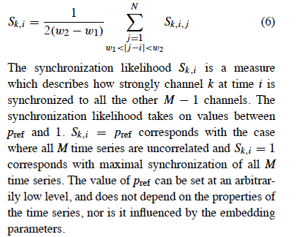

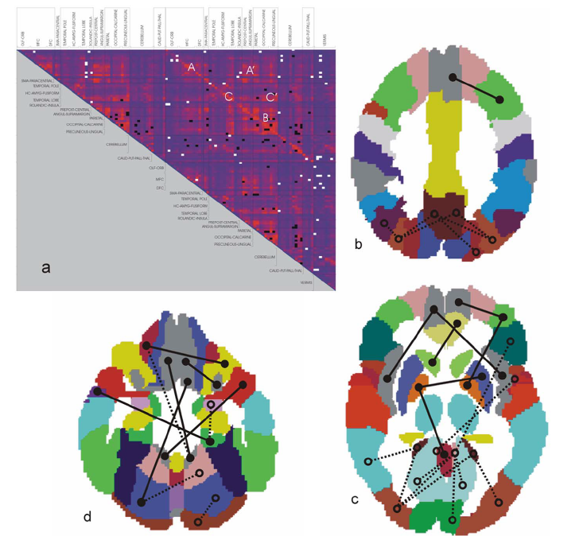The figure shows the synchronization (note that as the matrix is symmetric we just need one ‘side’) differences between the AD group and the control group. Black and white spots are brain areas pairs with increased or decreased synchronization. Interesting that there is an increase in frontal synchronization and a decrease in parietal and occipital areas. A possible explanation for this result would be that the loss of synchronization in parietal and occipital provokes an increase of synchronization in frontal areas, acting as a compensatory mechanism.

**Questions to be addressed in the Okayama Lab**

1. For our data set of 24 healthy subjects in resting state; Can we using ICA-based analysis find coherent resting state patterns?
2. The 10 components shown in the paper are spatially independent areas with low frequency fluctuations. However more and or different patterns may be found, and more importantly how the patterns are related needs to be explored. Which consistent patterns can we find with our data? and how to model them as networks? (this question is addressed in the technical paper Tech:2-20062012)

References

E. Sanz-Agirita et al. (2010) Loss of ‘Small-World’ Networks in Alzheimer’s Disease: Graph Analysis of fMRI Resting-State Functional Connectivity